**LAB PROGRAM 1 (INSURANCE DATABASE) Name: Tushar A Pai**

**USN: 1BM19CS174**

**Queries:**

|  |
| --- |
| Create database insurance; |
|  | use insurance; |
|  |  |
|  | create table person( |
|  | driver_id varchar(10), |
|  | name varchar(20), |
|  | address varchar(30), |
|  | primary key(driver_id) |
|  | ); |
|  |  |
|  | desc person; |
|  |  |
|  | create table car( |
|  | reg_num varchar(10), |
|  | model varchar(10), |
|  | year int, |
|  | primary key(reg_num) |
|  | ); |
|  |  |
|  | desc car; |
|  |  |
|  | create table accident( |
|  | report_num int, |
|  | accident_date date, |
|  | location varchar(20), |
|  | primary key(report_num) |
|  | ); |
|  |  |
|  | create table owns( |
|  | driver_id varchar(10), |
|  | reg_num varchar(10), |
|  | primary key(driver_id,reg_num), |
|  | foreign key(driver_id) references person(driver_id), |
|  | foreign key(reg_num) references car(reg_num) |
|  | ); |
|  |  |
|  | desc owns; |
|  |  |
|  | create table participated( |
|  | driver_id varchar(10), |
|  | reg_num varchar(10), |
|  | report_num int, |
|  | damage_amount int, |
|  | primary key(driver_id,reg_num,report_num), |
|  | foreign key(driver_id) references person(driver_id), |
|  | foreign key(reg_num) references car(reg_num), |
|  | foreign key(report_num) references accident(report_num) |
|  | ); |
|  |  |
|  | desc participated; |
|  |  |
|  | insert into person values('A01','Richard',' Srinivas Nagar'); |
|  | insert into person values('A02','Pradeep','Rajajinagar'); |
|  | insert into person values('A03','Smith','Ashoknagar'); |
|  | insert into person values('A04','Venu','N.R.Colony'); |
|  | insert into person values('A05','John','Hanumanth Nagar'); |
|  |  |
|  | commit; |
|  |  |
|  | select * from person; |
|  |  |
|  | insert into car values('KA031181','Lancer',1957); |
|  | insert into car values('KA041702','Audi',2005); |
|  | insert into car values('KA043408','Honda',2008); |
|  | insert into car values('KA052250','Indica',1990); |
|  | insert into car values('KA095477','Toyota',1998); |
|  |  |
|  | commit; |
|  |  |
|  | select * from car; |
|  |  |
|  |  |
|  | insert into accident values(11,'2001-01-03','Mysore Road'); |
|  | insert into accident values(12,'2021-01-03','Southend Circle'); |
|  | insert into accident values(13,'2020-03-03',' Bulltemple Road'); |
|  | insert into accident values(14,' 2017-02-08',' Mysore Road'); |
|  | insert into accident values(15,'2004-03-05','Kanakpura Road'); |
|  | commit; |
|  |  |
|  | select * from accident; |
|  |  |
|  | insert into owns values ('A01','KA052250'); |
|  | insert into owns values ('A02','KA043408'); |
|  | insert into owns values ('A03','KA031181'); |
|  | insert into owns values ('A04','KA095477'); |
|  | insert into owns values ('A05','KA041702'); |
|  | commit; |
|  |  |
|  | select * from owns; |
|  |  |
|  | insert into participated values ('A01','KA052250',11, 25000); |
|  | insert into participated values ('A02','KA043408',12, 50000); |
|  | insert into participated values ('A03','KA031181',13, 25000); |
|  | insert into participated values ('A04','KA095477',14, 3000); |
|  | insert into participated values ('A05','KA041702',15, 5000); |
|  | commit; |
|  |  |
|  | select * from participated; |
|  |  |
|  | update participated |
|  | set damage_amount = 2500 |
|  | where reg_num='KA031111'; |
|  |  |
|  | select * from participated; |
|  |  |
|  | insert into accident values(101,'2020-12-01','Xavier Road'); |
|  | insert into participated values('A01','KA031111',101, 1001); |
|  | commit; |
|  | select * from accident; |
|  | select * from participated; |
|  |  |
|  | insert into car values('KA01010', 'Accord', 2002); |
|  | insert into owns values('A02', 'KA01010'); |
|  | insert into accident values(200, '2008-12-01', 'Pinto Road'); |
|  | insert into participated values('A02', 'KA01010', 200, 500); |
|  | commit; |
|  |  |
|  | select * from car; |
|  | select * from owns; |
|  | select * from accident; |
|  | select * from participated; |
|  |  |
|  | select count(*) from accident where year(accident_date)=2008; |
|  | select count(*) from participated where reg_num in ( select reg_num from car where model="Accord"); |

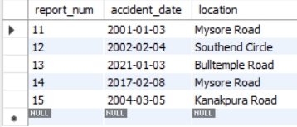

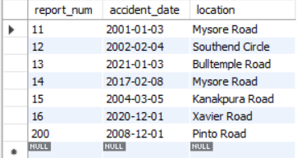

Accident Table

Accident Final Table

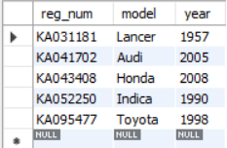

Car Table

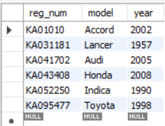

Car Final Table

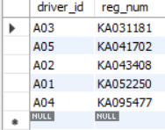

Owns Table

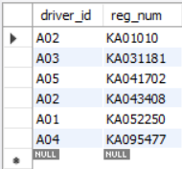

Owns Final Table

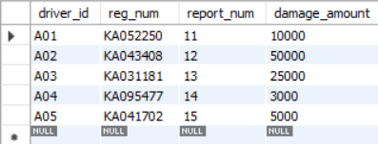

Participated Table

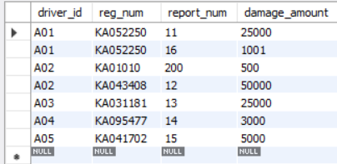

Participated Table Final

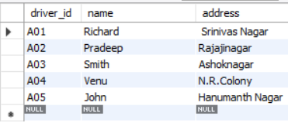

Person Table